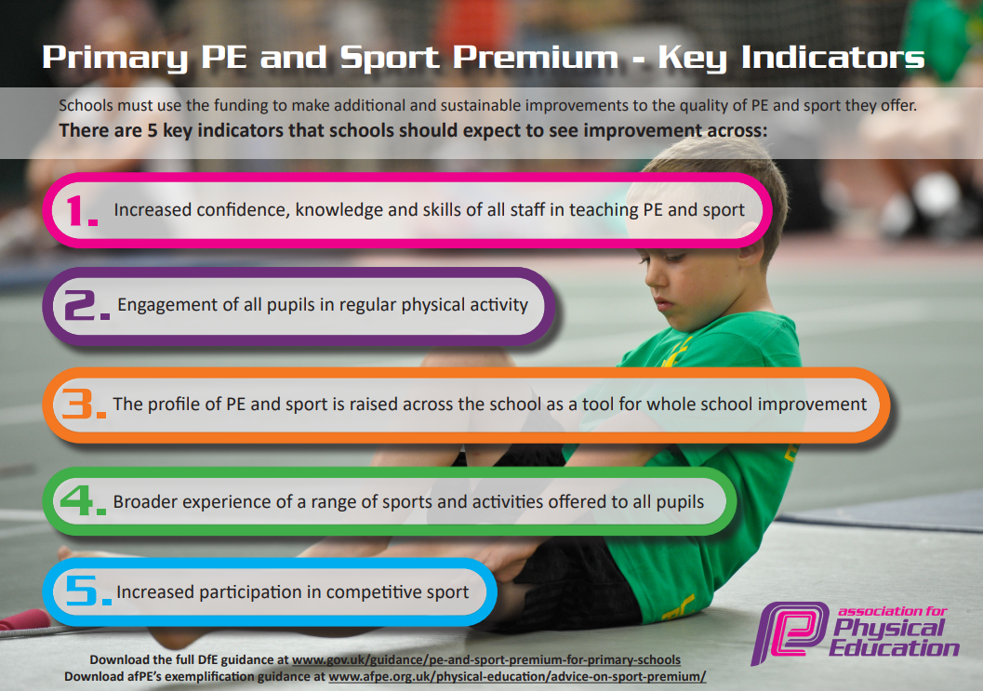

Review of last year’s main spending and key achievements

Please find below a snap shot of the key achievements and main spending from the academic year 20223-2023

Activity/Action | Impact | Comments
Bike 4 Health  Year 3 children received a full half term of bike riding training. We combined this with sending 4 members of school staff onto a British Cycle Lead Rider training day to allow staff to continue the biking provision for Appletree.  Key Steps Gymnastics  We entered 2 KS2 teams,1 KS1 team and an individual entry into the key steps gymnastics. We received training from a qualified gymnastic coach over a number of weeks.  Cross curricular orienteering enrichment day  After installing our very own bespoke orienteering course, the company came back in to offer us an enrichment experience for every child in Reception to Y4.  Year 3 and 4 football team  After many years of lockdown rules we finally had the chance to travel to other schools and play sport. A very keen and enthusiastic KS2 cohort requested a football team. We held trials and training sessions to enable us to take a large number of children to play a home and away fixture against a local school. | We can now state that all the current Year 4 children are bike riders.  The children have experienced off site cycling days led by the qualified school staff.  We invested in our own set of school bikes plus and additional 2 adult bikes so that the we have the opportunity to plan these days and sessions in throughout the year. We hope to maximize the chances for the children to ride bikes in school time.  After travelling to and entering the first round of the competition, we were successful with 1 KS2 team, 1 KS1 team and the individual entry. This meant that we went forward to the Tyne and Wear games to represent North Tyneside against some of the best gymnasts in the North East. Whilst we did not podium in the KS teams, our individual entry won 1st place over all.  This was an amazing achievements for all teams.  The children used timing chips to register the time taken for their respective challenges. This was a mixture of individual and partner work. There was a live leaderboard and could be filtered for year groups to see who was leading.  The two mixed teams were able to play fairly and competitively against the other school. They represented AGFS well and looked the part in their strips. The ganes were refereed by local Middle School Sports leaders so it was another chance to make links with the local community. | Pupil voice was carried out before, during and after the bike riding and all children were extremely positive about it.  We received comments from the wider community whilst off site as we were wearing our branded high vis jackets who commented that it was nice to see the children out and about in the local community.  This was undoubtedly our biggest spending from last year. We invested heavily but the resources, equipment and staff knowledge will have longevity for many years to come.  It was a wonderful opportunity to participate in a competitive environment. The children wore the AGFS leotards with great pride and all the children were thrilled to represent their school. Their success was shared with all stakeholders and celebrated in assembly.  It was a successful day that enabled the children to take part in a competitive environment against others in the school. They put into practice what they had learned during cross curricular sessions.  It was great to see the children enjoy themselves in a different environment. Both games were well supported by family and spectators and the school received excellent feedback and comments. It is something we will look to run again in 2023-2024.

Key priorities and Planning for 2023-2024

Action – what are you planning to do | Who does this action impact? | Key indicator to meet | Impacts and how sustainability will be achieved? | Cost linked to the action
Introduce an open ended (non fixed) moveable set of climbing apparatus.  All year 3 children bike riders  Bike 4 Health  Lunch time sports coaching  Autumn term  CPD Tag Rugby  (and half day release)  CPD – Attending termly PE network meeting  Day release for PE subject lead  CPD Gymnastics Day  3x Staff. On the result of the staff audit, identification of gymnastics CPD.  (December)  PE Curriculum resources:  Tag Rugby belts  Bike maintenance  Annual maintenance and review of sports equipment  Annual subscription to Jump Start Jonny  Year 4 trail and challenge orienteering morning.  Enhanced play provision for KS2  (spring term)  CPD  3x Staff. On the result of the staff audit, identification of general PE movement – ball skills etc CPD.  (summer 1)  CPD  3x Staff. On the result of the staff audit, identification of active movement CPD.  (spring 1)  British Cycling Ride Leader Training  (Summer 1)  Bike fortnight!  All KS2 pupils  Whole staff PE CPD  (Andy Cartwright) | We noticed as a potential knock on from Covid that the children needed more opportunities to develop gross motor and grip strength activities to help with body coordination, as well as managed risk and decision making.  Building on the successful implementation of buying a  set of school bikes and training the current Y4 children to ride, we rolled out the offer to Y3 children. This means all children in the KS are bike riders. A life long skill that will help to increase the engagement and participation of the children.  Twice weekly external sports coaching delivers an hour session to KS2 children.  External specialists delivering a series of CPD for the class teachers, accumulating with a local level competition with other schools.  All Y4 children.  The PE subject coordinator attended. Local and National updates received, Premium funding updates.  PE lead shared with HT of main changes.  Back in school – day release to implement changes, carry out observations and staff audit.  3 teachers identified the need for some gymnastic CPD. (1x ECT teacher, 1x new to a year group)  (North Tyneside Council)  Allowing teachers to have the resources needed to deliver high quality sessions.  All children having all equipment in safe working order, checked and replaced.  Enabling them to take part in safe PE sessions.  All children across the whole school. Jump Start Jonny is an online movement video, providing activity breaks, movement breaks, wake up shake up type dance routines for the children to follow.  All 60 children had the opportunity to attend a competitive orienteering challenge. They worked on mapping skills, directional awareness as well as team work and decision making.  KS2 children have the opportunity to take part in lunchtime activities on Tuesdays/Thursday with an external coach.  The coach delivers structured games in a fun environment.  External specialists delivering a series of CPD for the class teachers.  All Y1 children. (Andy Cartwright)  External specialists delivering a series of CPD for the class teachers. (Little Movers)  CPD for 7 school staff in becoming ride leaders.  Building on our newly qualified staff ride leaders, we have planned a bike fortnight for all KS2 children. The children will all receive a half day on or off site ride or some children will receive a full day ride. This allows the staff to practice their new skills as well as enhancing the children’s opportunities for cycling.  After observations, we wanted some ‘quick wins’ of how we can ensure our PE lessons are maximizing the opportunity for our young people to be active.  In staff meeting time – all staff attended a practical session where some Year 1 children attended so we could see the external specialist in a realistic situation. | Key indicator 2 -The engagement of all pupils in regular physical activity – the Chief Medical Officer guidelines recommend that all children and young people aged 5 to 18 engage in at least 60 minutes of physical activity per day, of which 30 minutes should be in school.  Key indicator 4: Broader experience of a range of sports and activities offered.  Key indicator 3: The profile of PE and sport is raised across school. (and shared with stakeholders)  Key Indicator 2: The engagement of all pupils in regular physical activity  Key Indicator 1: Increased confidence, knowledge, and skills of all staff in teaching PE and sport.  Key indicator 5: Increased participation in competitive sport.  Key indicator 3: The profile of PE and sport is raised across school. (celebrated in assembly and shared with stakeholders)  Key Indicator 1: Increased confidence, knowledge, and skills of subject leader.  Key indicator 3: The profile of PE and sport is raised across school.  Key Indicator 1: Increased confidence, knowledge, and skills of subject leader.  Key indicator 4: Broader experience of a range of sports and activities offered.  Key Indicator 2: The engagement of all pupils in regular physical activity  Key indicator 2 -The engagement of all pupils in regular physical activity – the Chief Medical Officer guidelines recommend that all children and young people aged 5 to 18 engage in at least 60 minutes of physical activity per day, of which 30 minutes should be in school.  Key indicator 5: Increased participation in competitive sport.  The children competed off site against others in their group and also other groups from other days.  Key indicator 2 -The engagement of all pupils in regular physical activity – the Chief Medical Officer guidelines recommend that all children and young people aged 5 to 18 engage in at least 60 minutes of physical activity per day, of which 30 minutes should be in school.  Key Indicator 1: Increased confidence, knowledge, and skills of subject leader.  Key Indicator 1: Increased confidence, knowledge, and skills of subject leader.  Key Indicator 1: Increased confidence, knowledge, and skills of subject leader.  Key indicator 2 -The engagement of all pupils in regular physical activity  Key indicator 3: The profile of PE and sport is raised across school.  Key indicator 4: Broader experience of a range of sports and activities offered.  Key indicator 3: The profile of PE and sport is raised across school.  Key indicator 4: Broader experience of a range of sports and activities offered.  Key Indicator 1: Increased confidence, knowledge, and skills of subject leader. | More pupils meeting their daily physical activity goal. With the equipment being available all year round and used in different configurations to challenge the children.  A life long skill that will hopefully engage and interest them. The British Cycling trained Staff will continue to build opportunities and be taken on bike rides on and off site.  More pupils meeting their daily physical activity goal. A structured environment for competitive sport during lunch times. The coach promotes fair play and leadership to the children.  Teachers more confident to deliver effective PE, upskilling teacher knowledge and raising the standard of PE lessons. The children thoroughly enjoyed representing the school at this event. The children wore the AGFS strips with pride.  The release time enables subject coordinator to roll out some targets and review the impact of what has been achieved so far.  Teachers more confident to deliver effective PE, upskilling teacher knowledge and raising the standard of PE lessons.  Teachers more confident to deliver effective PE and can build on the foundations of the planning scheme.  Resources and equipment to enable staff to deliver and children to experience opportunities.  Children meeting and then exceeding their total daily minutes of physical activity.  The children were taken to the Rising Sun Country park in their local area. It was a chance to explore and learn about a new location. It is hoped that the children will then use the location with their own families and share their experiences.  All the children who attend enjoy it and the lunch staff have reported less playground issues, with the children also showing more fair play and acceptance towards each other.  Teachers more confident to deliver effective PE, upskilling teacher knowledge and raising the standard of PE lessons.  Teachers more confident to deliver effective PE, upskilling teacher knowledge and raising the standard of PE lessons.  A life long skill that can be used form many years to come. More staff trained allows more opportunity for out young people to make the use of our school bikes safely in the local area.  Enjoyment of all pupils involved. All children will have a ride/activities planned to meet their needs.  Pupil voice will be collected after the events. Shared information across the school with stakeholders to enhance the profile of sport at Appletree.  All staff took some take away ideas with them after the session. A copy of the sessions / activities available on the shared drive for reference. | £3500.  £3080  £600  £360  £102  £185  £102  (half day release)  £410  £100 Tag Rugby  £92 Bikes  £110  £249  £450  £300  (still on going)  £920  £2265  (Cover costs for teacher release)  £300

Key achievements 2023-2024
This template will be completed at the end of the academic year and will showcase the key achievements schools have made with their Primary PE and sport premium spending.

Activity/Action | Impact | Comments

Signed off by:

Head Teacher: | (Name)
Subject Leader or the individual responsible for the Primary PE and sport premium: | (Name and Job Title)
Governor: | (Name and Role)
Date:

