Bike for Health

Rationale
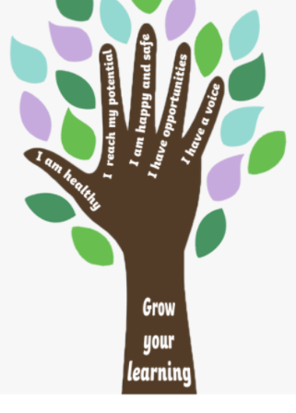

At Appletree we wanted to offer and allow the children to experience something a little different.
We felt that our main ‘grow your learning’ drivers could be achieved through cycling, with a particular focus on ‘I am healthy’ and ‘I have opportunities’

Process
We got in contact with Bike4Health to discuss how we could get our children involved in cycling and what benefits the children would get from the sessions.
We started with one of the Year 3 classes, and all the children received 6x1.5hours cycle training. The training covered – carrying out bike checks, adjusting seat positions and helmet straps, cornering, bike confidence, changing gears and road signalling.
Part way through the training, 4 teachers enrolled on a British Cycling Ride Leader training, which would allow the staff to take groups off site on their bikes.

Impact
At the end of the training the 16 most competent road riders were taken off site into the local area and completed a 7mile ride using small side streets and the local wagon ways. It was a brilliant morning and the children thoroughly enjoyed it.

Because of the positive results, we booked in the other Year3 class to repeat the same process.

Headlines
At the beginning of the training:
28 non-riders
At the end of the training:
0 non-riders.
Every single child in Year 3 can now ride a bike

Pupil Voice
What did you enjoy about the biking?
“I liked learning about riding in 1s and 2s” “I liked how we can check our own bikes and check they are safe” “I liked how the bikes had gears because my bike at home does not” “I liked that there was a rider group and a non rider group so we could learn at the right place”

How do you think you did during the sessions?
“I am a lot better at steering now” “I am proud of myself as I couldn’t do it at the beginning”

What is your next steps/challenge?
“I need to keep up my practicing at home” “I need to increase my speed when safe” “I need to practice using both brakes not just one”

Next Steps
We have invested in our very own set of 16 children bikes, 2 adult bikes and helmets and spares/repairs kit. We have full watertight safe storage where all the bikes are kept clean and maintained.
We hope to run the cycling program out to the new Year 3 children, which would enable us to have a full Key Stage of bike riders.
We currently have plans to extend the biking offer so that we maximise our bikes, including regular biking sessions where the less confident riders get more practice on site, and the more competent riders can ride further off site.
There has also been interest from other staff who would like to be enrol on the next British Rider Cycle Leader training.

