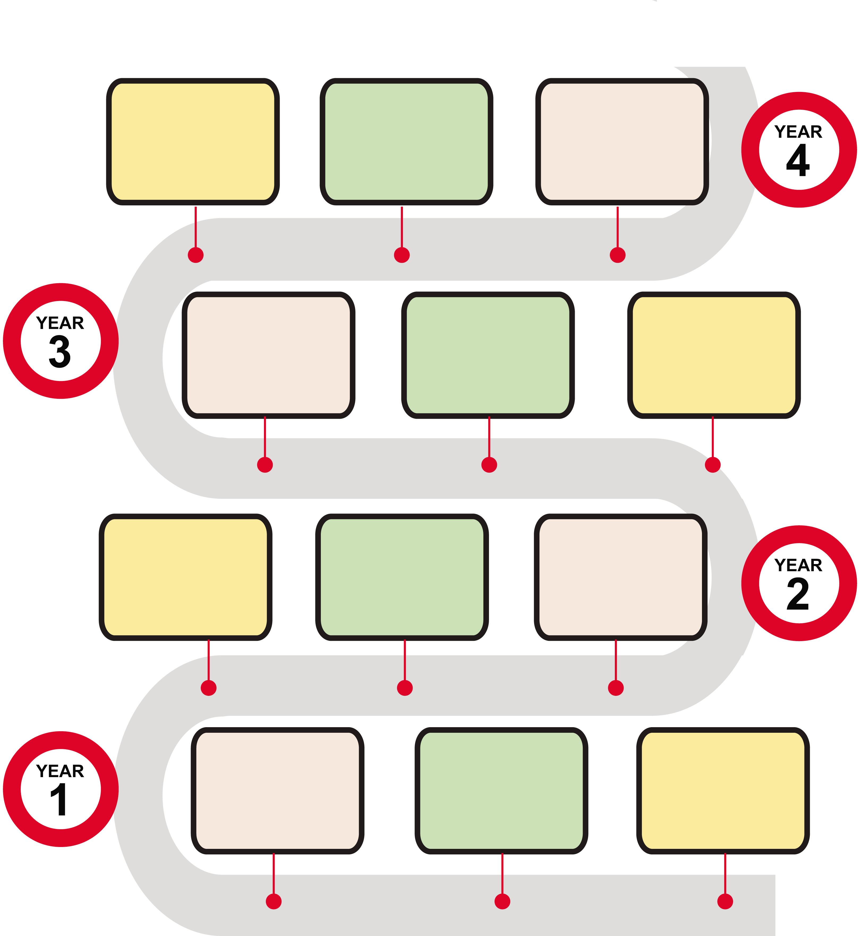
Sound
Recognise that sounds get fainter as the distance from the sound’s source increases.
Know sounds are made through vibrations that travel to the ear.
Find patterns between the volume of a sound and the strength of the vibrations that produced it.
Find patterns between pitch of a sound and features of the object that produced it.
Living Things & Habitats
Identify and name a variety of living things (plants and animals)
Classify plants/animals by their specific characteristics.
Recognise that environments changing environments can pose dangers to specific habitats.
Identify how animals and plants are adapted to suit their environment in different ways and that adaptation may lead to evolution.
Connected learning- Maths- reading scales, recording/interpreting data (decibels). Music dynamics and pitch.

Plants
Identify and describe the functions of different parts of flowering plants: roots, stem/truck, leaves and flowers.
Investigate what plants need for life and growth (air, light, water, nutrients from soil, and room to grow).
Explore the life cycle of flowering plants, including pollination, seed formation and seed dispersal.
Light & Shadows
Name light sources identify materials that are opaque, translucent and transparent.
Understand the dangers of looking at the sun/bright lights and investigate ways to protect the eyes.
Know that shadows are formed when light from a light source is blocked by a solid object.
Find patterns in the way that the size of shadows change.
Connected learning- Geography – weather/seasons and impact on life.

Animals including humans

Identify that humans and some other animals have skeletons and muscles for support, protection and movement.
Understand that animals, including humans, need the right types and amount of nutrition from what they eat to survive.

Connected learning- Maths- recording of data in tables, use of written methods for total costs.
STEM Week

Animals including Humans
Describe/draw/discuss the functions of the digestive system in humans.
Identify the different types of teeth in humans and investigate functions.
Compare the teeth of carnivores and herbivores and suggest
reasons for differences.

Living Things & Habitats-Food chains
Construct and interpret a variety of food chains.
Identify producers, predators and prey.
Connected learning- STEM Week
Geography- Features of hot and cold places .Why are rainforests important to us?

Spring- Animals Including Humans
Identify and name a variety of common animals
including fish, amphibians, reptiles, birds and mammals.
Identify and name a variety of common animals that are carnivores, herbivores and omnivores.
Describe and compare the structure of a variety of common animals (fish, amphibians, reptiles, birds and mammals including pets).
Identify, name, draw and label the basic parts of the human body and say which part of the body is associated with each sense.

Explore seasonal changes in weather and impact on plants/animals in local area.
Connected learning- Geography-What’s the weather like in the UK? STEM Week

States of Matter
Compare and group materials together, according to whether they are solids, liquids or gases.
Observe how some materials change state when they are heated or cooled, and measure the temperature at which this happens in degrees Celsius (°C), building on their teaching in mathematics.
Explore the water cycle the part played by evaporation and condensation.
Electricity
Identify appliances that run on electricity.
Construct a simple series electrical circuit, identifying and naming its basic parts, including cells, wires, bulbs, switches and buzzers. Use a circuit to investigate switches.
Investigate conductors and insulators.
Connected learning: Maths reading scales (temperature degrees Celsius °C), data loggers.

Autumn- Living things and their Habitats-
Explore and compare the differences between things that are living, dead, and things that have never been alive.
Identify habitats and understand how they provide for the basic needs of different kinds of animals and plants, and how they depend on each other.
Identify features plants/animals have to help them survive in habitat.
Identify and name a variety of plants and animals in their habitats, including microhabitats.
Describe how animals obtain their food from plants and other animals, using the idea of a simple food chain.
Identify and name different sources of food.
Connected learning- Geography-What’s it like to live by the coast? Key features of different environments.
Autumn Our Bodies
Identify and name main body parts and understand their function.
Name the 5 senses and body parts associated with them.
Through practical activities and experiments ask questions and talk about findings.
Everyday Materials
Identify objects and materials they are made from.
Name a variety of everyday materials, including wood, plastic, glass, metal, water and rock.
Describe the simple physical properties of a variety of everyday materials.
Compare and group everyday materials by their physical properties.
Explore seasonal changes in weather and impact on plants/animals in local area.
Connected learning- Geography- Fieldwork/observational skills.

Summer - Plants
Identify and name a variety of common wild and garden plants, including deciduous and evergreen trees
Identify and describe the basic structure of a variety of common flowering plants, including trees.

Explore seasonal changes in weather and impact on plants/animals in local area.

Connected learning- Geography Comparing and Contrasting hot/cold regions (impact on what grows there).

Autumn- Rocks, Soils and Fossils
Compare and group rocks by their appearance/physical properties.
Test the properties of rocks.
Describe how fossils are formed.
Recognise that soils are made from rocks and organic matter.
Forces & Magnets
Compare how things move on different surfaces. (friction))
Investigate if magnets attract or repel.
Test materials to identify properties e.g. magnetic/non-magnetic.
Know magnets have 2 poles.
Make predictions if 2 poles will attract/repel.
Connected learning- History Ancient civilisations – Stone Age.
Significant historical figure -Mary Anning- palaeontology.

Summer -Plants
Observe and describe how seeds and bulbs grow into mature plants.
Investigate and describe how plants need water, light and a suitable temperature to grow and stay healthy.

Animals Including Humans
Investigate and describe the basic needs of animals, including humans, for survival (water, food and air) .
Describe the importance for humans of exercise, eating the right amounts of different types of food, and hygiene.

Connected learning- Physical features of coastline and impact on what can grow there. DT food tech- ‘Perfect Pizzas’.

Spring- Uses of Everyday Materials
Identify and compare the suitability of a variety of everyday materials, including wood, metal, plastic, glass, brick, rock, paper and cardboard for particular uses.
Investigate how the shapes of solid objects made from some materials can be changed by squashing, bending, twisting and stretching.
Animals Including Humans
Notice that animals, including humans, have offspring which grow into adults.
Be introduced to the processes of reproduction and growth in animals (life cycles).

Connected learning- Geography comparing and contrasting different environments. STEM Week

Little Pips
Nursery

Reception
Exploring the world around us.
Caring for living things.
How do the seasons change?
Investigating forces such as floating/sinking, pushes/pulls.
Explore the natural world around them- habitats
Name plants and parts of plants. Know and demonstrate how to plant bulbs (make predictions)
Understand the key features of the life cycle of a plant and an animal (sequence)
Describe changes to trees and woodland plants in autumn observe how animals behave differently as seasons change.
Talk about change of state of materials e.g. combing different materials and properties.
Observe and interact with natural processes(ice melting/sound vibrations/light travelling through transparent materials /shadows/magnets/floating
Explore natural materials, indoors and outside.
Make respectful observations of living things.
Learn how to care for living things.
Actively explore the properties of everyday materials through spontaneous experimentation, narrating findings.
Collect particular materials for a purpose.
Make mechanisms such as pegboard cogs and other simple construction kit components such as wheels and axles work to a particular end.
Answer closed and anticipatory questions in simple adult led experiments about the properties of materials

